Question 1
2 pts
Which compiler flag is required to enable OpenMP support in GCC?
Group of answer choices
- -enable-omp
- -fopenmp
- -openmp
- #pragma omp
- -omp

Question 2
2 pts
In what ways can you to set the number of threads in OpenMP?
Group of answer choices (multiple answers are included)
- Using #pragma omp parallel num_threads(n)
- Setting the OMP_NUM_THREADS environment variable
- Calling the function omp_set_num_threads(n)
- Using #define NUM_THREADS before #pragma omp parallel

Question 3
2 pts
What is the function of omp_get_thread_num() in OpenMP?
Group of answer choices
- Returns the maximum number of threads supported
- Returns the total number of available cores
- Returns the ID of the calling thread
- Returns the number of active threads

Question 4
2 pts
Which of the following statements about the #pragma omp critical directive is true?
Group of answer choices
- It allows only one thread to execute the enclosed code at a time.
- It guarantees that all threads execute the enclosed code exactly once.
- It forces all threads to stop execution until all reach this point.
- It allows only one thread to execute the enclosed code.

Question 5
2 pts
Which OpenMP clause ensures that a private variable is initialized with the original value before entering a parallel region?
Group of answer choices
- threadprivate
- lastprivate
- firstprivate
- Private

Question 6
2 pts
What is the default scheduling policy if #pragma omp for schedule(...) does not specify a scheduling type?
Group of answer choices
- none
- static
- guided
- dynamic
- auto

Question 7
2 pts
What is the primary advantage of using the reduction clause in OpenMP?
Group of answer choices
- It prevents the need for critical sections when updating a shared variable.
- It ensures that each thread executes only one loop iteration.
- It automatically parallelizes any function.
- It allows variables to retain their values across different threads.

Question 8
2 pts
When can a thread be assigned a task from the task queue?
Group of answer choices (multiple answers are included)
- After executing the last instruction in a task
- At the #pragma omp taskwait directive
- At the #pragma omp task directive
- At the #pragma omp taskyield directive
- At the #prgama omp barrier directive
- At all implicit barriers
- At the #pragma omp taskassign directive

Question 9
2 pts
What is the preferred alternative among the following ways to parallelize the force calculations in the N-body simulations?
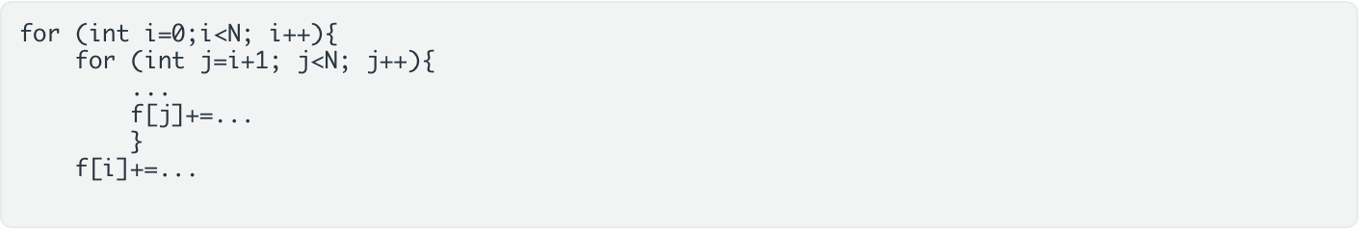

- #pragma omp parallel for private(f)
- #pragma omp parallel for schedule(dynamic) reduction(+:f[:N])
- #pragma omp parallel for schedule(dynamic,8) reduction(+:f[:N])
- #pragma omp parallel for schedule(static) reduction(+:f[:N])
- #pragma omp parallel for schedule(dynamic,1) private(f)
- #pragma omp parallel for reduction(+:f[:N])
- #pragma omp parallel for schedule(guided,8) reduction(+:f[:N])
- #pragma omp parallel for schedule(static,1) reduction(+:f[:N])
- #pragma omp parallel for schedule(dynamic,1) reduction(+:f[:N])
- #pragma omp parallel for schedule(static,8) reduction(+:f[:N])

Question 10
2 pts
What is meant with the relaxed consistency model in OpenMP
Group of answer choices
- All threads can read shared variables simultaneously
- All threads can write to a shared variable simultaneously without cache coherence problems
- Threads can run asynchronously
- Private data can be inconsistent between threads
- All threads can modify shared variables
- Threads are allowed to cache a private value of a shared variable until a synchronization point

Question 11
2 pts
What is false sharing?
Group of answer choices
- It is when caches on different levels store different values of the same variables
- It is a cache miss due to another thread has updated the data
- It is when different threads caches private and different values of a shared variable
- It is a cache miss when you read one element but another thread has updated another element on the same cache line

